Game of Thrones

Islam Islamov - 444601

5/11/23

## 1 Game of Thrones

***Game of Thrones*** is an American [fantasy](https://en.wikipedia.org/wiki/Fantasy_television) [drama](https://en.wikipedia.org/wiki/Drama_(film_and_television)) television series created by [*David Benioff*](https://en.wikipedia.org/wiki/David_Benioff) and [*D. B. Weiss*](https://en.wikipedia.org/wiki/D._B._Weiss) for [*HBO*](https://en.wikipedia.org/wiki/HBO). It is an adaptation of [*A Song of Ice and Fire*](https://en.wikipedia.org/wiki/A_Song_of_Ice_and_Fire), a series of fantasy novels by [*George R. R. Martin*](https://en.wikipedia.org/wiki/George_R._R._Martin), the first of which is [*A Game of Thrones*](https://en.wikipedia.org/wiki/A_Game_of_Thrones). The show was shot in the United Kingdom, Canada, Croatia, Iceland, Malta, Morocco, and Spain. It premiered on HBO in the United States on April 17, 2011, and concluded on May 19, 2019, with 73 episodes broadcast over eight seasons.

Set on the fictional continents of *Westeros and Essos*, *Game of Thrones* has a large [ensemble cast](https://en.wikipedia.org/wiki/Ensemble_cast) and follows several [story arcs](https://en.wikipedia.org/wiki/Story_arc) throughout the course of the show. The first major arc concerns the [*Iron Throne*](https://en.wikipedia.org/wiki/Iron_Throne_(A_Song_of_Ice_and_Fire)) of the [*Seven Kingdoms*](https://en.wikipedia.org/wiki/World_of_A_Song_of_Ice_and_Fire#Seven_Kingdoms) of *Westeros* through a web of political conflicts among the noble families either vying to claim the throne or fighting for independence from whoever sits on it. The second focuses on the last descendant of the realm’s deposed ruling dynasty, who has been exiled to *Essos* and is plotting to return and reclaim the throne. The third follows the *Night’s Watch*, a military order defending the realm against threats from beyond Westeros’s northern border.

|  |
| --- |
| Daenerys. |

## 2 Some Graphs based on ratings of each season

### 2.1 Summary of basic statistics :

Warning: package 'lubridate' was built under R version 4.2.2

Warning: package 'timechange' was built under R version 4.2.2

Season No..of.Episode..Season. No..of.Episode..Overall.  
 Min. :1.000 Min. : 1.000 Min. : 1   
 1st Qu.:2.000 1st Qu.: 3.000 1st Qu.:19   
 Median :4.000 Median : 5.000 Median :37   
 Mean :4.205 Mean : 5.192 Mean :37   
 3rd Qu.:6.000 3rd Qu.: 7.000 3rd Qu.:55   
 Max. :8.000 Max. :10.000 Max. :73   
 Title.of.the.Episode Running.Time..Minutes. Directed.by   
 Length:73 Min. :49.00 Length:73   
 Class :character 1st Qu.:52.00 Class :character   
 Mode :character Median :55.00 Mode :character   
 Mean :56.95   
 3rd Qu.:58.00   
 Max. :81.00   
 Written.by Original.Air.Date U.S..Viewers..Millions.  
 Length:73 Min. :2011-04-17 Min. : 2.200   
 Class :character 1st Qu.:2012-05-27 1st Qu.: 3.900   
 Mode :character Median :2014-05-18 Median : 6.640   
 Mean :2014-09-01 Mean : 6.448   
 3rd Qu.:2016-05-22 3rd Qu.: 7.820   
 Max. :2019-05-19 Max. :13.610   
 Music.by Cinematography.by Editing.by IMDb.Rating   
 Length:73 Length:73 Length:73 Min. :4.000   
 Class :character Class :character Class :character 1st Qu.:8.500   
 Mode :character Mode :character Mode :character Median :8.800   
 Mean :8.741   
 3rd Qu.:9.300   
 Max. :9.900   
 Rotten.Tomatoes.Rating..Percentage. Metacritic.Ratings Ordered   
 Min. : 47.00 Min. :2.600 Length:73   
 1st Qu.: 89.00 1st Qu.:6.500 Class :character   
 Median : 96.00 Median :8.500 Mode :character   
 Mean : 91.97 Mean :7.818   
 3rd Qu.:100.00 3rd Qu.:9.100   
 Max. :100.00 Max. :9.700   
 Filming.Duration Novel.s..Adapted Synopsis   
 Length:73 Length:73 Length:73   
 Class :character Class :character Class :character   
 Mode :character Mode :character Mode :character

### 2.2 Viewership in US over time :

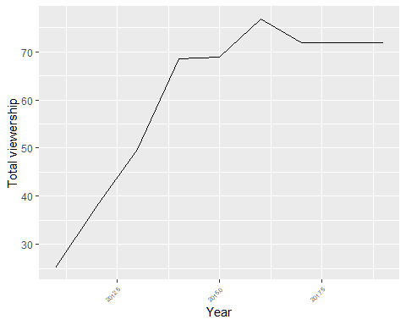

### 2.3 Viewership in US over time by each season :

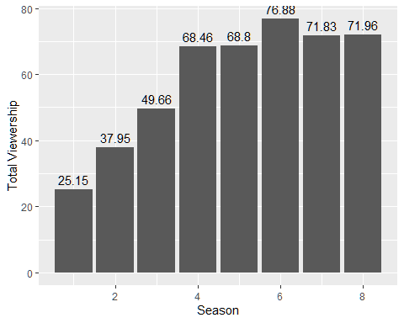

### 2.4 A short overview of first graph :

#### As we can observe from graph of total viewership over time by each year, it is very obvious that the show grew in popularity over time. With starting position of less than 15 million of views and ending with total of more than 70 million, maximizing at more than 75 million between periods from 2015 to 2016.

### 2.5 A short overview of second graph :

#### Similar situation is observed in second graph of viewership by seasons, we can see that between season 5 and 7 the viewership hit its peak of popularity with more than 76.88 millions viewers in total( period between 2015 and 2016).